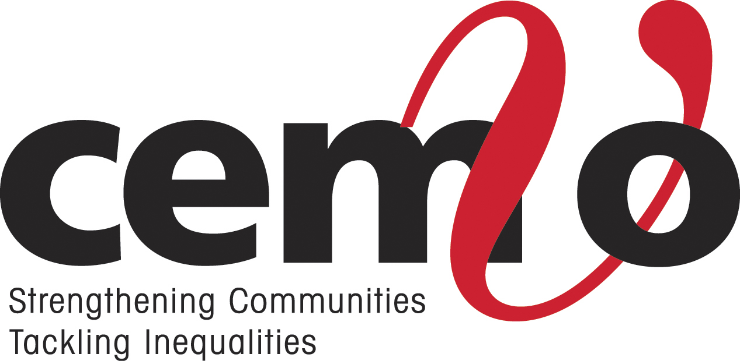

JOB DESCRIPTION

Responsible to: Chief Executive

Job Title: Human Rights & Race Equality Officer

Hours of Work: Full- Time (35 hours per week)

Salary: £28,000 PA + 4% employers pension contribution

Length of Contract: Fixed Term to 31st March 2026 (possibility of extension depending on continued funding).

Office Base: Glasgow (Hybrid)

Main Objectives of the job

To provide the lead in delivering human rights (& race equality) mainstreaming support to organisations across all sectors.

To deliver human rights (and race equality) training sessions across all sectors.

To help organise and facilitate engagement between public service providers and EM groups / communities.

Specific Duties and Responsibilities

- To promote race equality and human rights (R4HR) mainstreaming support programme to organisations across all sectors.

- To deliver human rights (and race equality) mainstreaming consultancy support to organisations across all sectors and producing summary reports that record discussion areas and agreed outcomes / actions for implementation.

- To support organisations across all sectors in implementing human rights (and race equality) actions following CEMVO consultancy support and track / monitor progress.

- To design and deliver high quality human rights (and race equality) training to organisations across all sectors, ensuring that it is pitched at a level where organisations are able to develop good human rights (and race equality) policies and practices.

- To organize and facilitate human rights (and race equality) learning webinars which will aim to stimulate discussion and learning on areas such as EM workforce development, EM data gathering, positive action, effective EM community engagement, etc.

- To identify and upload onto CEMVO website, and draft bulletins / publications / newsletters on human rights (and race equality) good policies and practices and disseminate widely so that learning can be shared across all sectors.

- To work with the EM community engagement officer to support organisations across all sectors in engaging with intersectional EM communities as part of implementing their actions or policy / service development consultations or general engagement with the aim of ensuring EM lived experiences help inform policy and good practice development.

- To help develop any improved structures (including engagement agreements, etc) for implementation of the race equality and human rights mainstreaming programme and ensure monitoring and evaluation processes are in place to record the meeting of project outcomes.

- To develop promotional materials for the race equality and human rights mainstreaming programme where needed.

- To draft CEMVO responses to human rights (and race equality) related policy consultations and organize EM engagement where needed for lived experiences to help inform policy development

- To lead and work with the Chief Executive in responding to human rights (and race equality) related consultations and sit on high level policy tables / advisory groups to help advance the race equality and human rights agenda in Scotland, and contribute to policy development and strategies

- To work within the team in providing quarterly and end of year reports to the funder when requested by the Chief Executive

- To ensure annual and quarterly work plans are in place so as to meet outputs and outcomes of the R4HR mainstreaming support programme

- To continually increase own awareness and knowledge of human rights and race equality issues, including legislation, policies and practices

- To undertake other appropriate duties and tasks that will enhance the work of CEMVO Scotland as requested by the Chief Executive, including drafting of funding applications

- This job description is not an exhaustive list of responsibilities and tasks but indicates the main responsibilities required from employees in this role. The organisation reserves the right to vary or amend the duties and responsibilities of the post-holder at any time according to the needs of the organisation’s business.

- There is a requirement to work flexibly, including home working, working evenings and weekends as necessary in order to ensure appropriate fulfillment of duties.

PERSON SPECIFICATION

ESSENTIAL

- Extensive knowledge, understanding and experience of human rights, particularly around addressing institutional discrimination and organizational development in mainstreaming of human rights policies and practices.

- Extensive knowledge and understanding of current human rights legislative framework, Public Sector Equalities Duties, and reporting cycles / processes for mainstreaming reports and outcomes.

- Extensive knowledge of the human rights (and race equality) political and policy landscape in Scotland

- Extensive experience in designing and delivering high quality human rights (and race equality) training to a wide variety of audiences across all sectors and undertaking evaluation processes to measure successful outcomes

- Extensive knowledge, experience and understanding of Race Equality and how this can be implemented in policies and practices within organisations

- Skills and experience in drafting bulletins, publications, and newsletters, etc on good human rights (and race equality) policies and practices

- Extensive background in human rights policy development, with the ability to draft high quality responses to consultations and ability to contribute to high level human rights / race equality advisory groups

- Good knowledge and understanding of community engagement standards and processes

- Strong knowledge and understanding of Equality Impact Assessment (EQIA) processes

- Good communication, inter-personal and networking skills, including good presentational and public speaking skills

- Commitment to the development of the ethnic minority voluntary sector, as well as good understanding of the issues affecting the sector

- Demonstrated experience in thinking and working strategically to progressing human rights and race equality in Scotland

- Ability to meet targets and deadlines to achieve project outcomes

- Good organisational skills, including organising events and planning own work load

- Excellent writing and report writing skills, including drafting of detailed briefing papers

- Ability to travel across Scotland to attend events, meetings, conferences, etc.

- Good knowledge and skills in using online platforms such as Zoom and Microsoft Teams to deliver events

- Able to be flexible in working occasional weekends and evenings and working from home.

DESIRABLE

- Experience of undertaking consultancy work, especially in the area of implementation of human rights / race equality policies and practices to address and improve race / equality outcomes within mainstream organisations

